Test case 1: Login and registration services

After starting the server, start the app on an Android device. The login page will appear. As there’s no account at this time, click the ‘SIGN UP’ link:

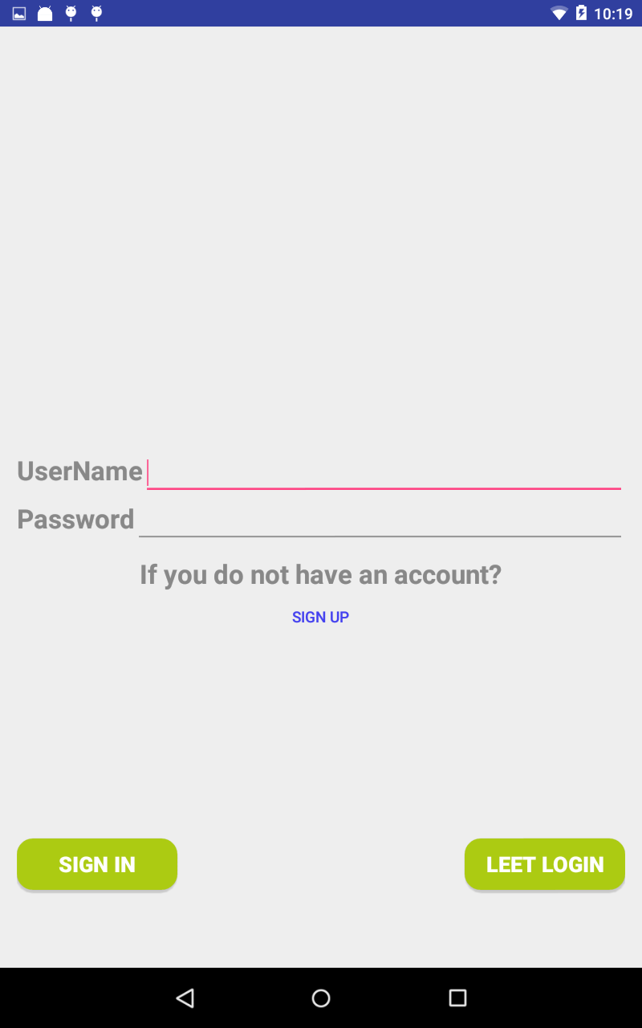

You will be required to input your username and password, your LeetCode username LeetCode credential and your email address. All of these items are mandatory.

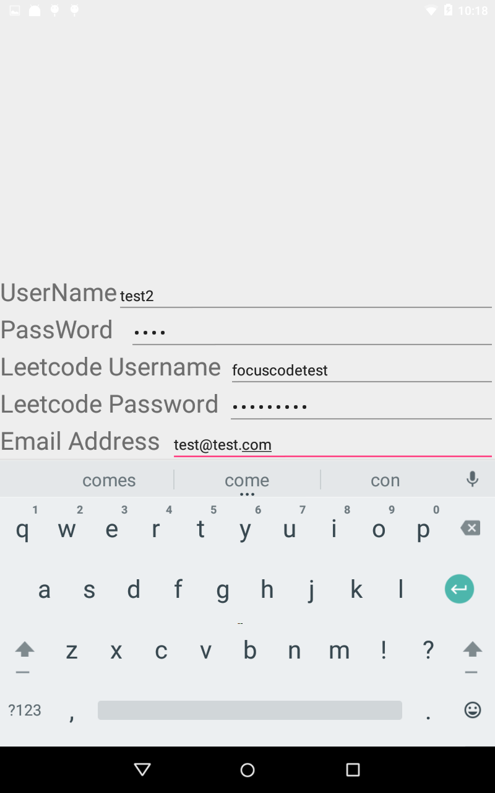

In case you left either one of these item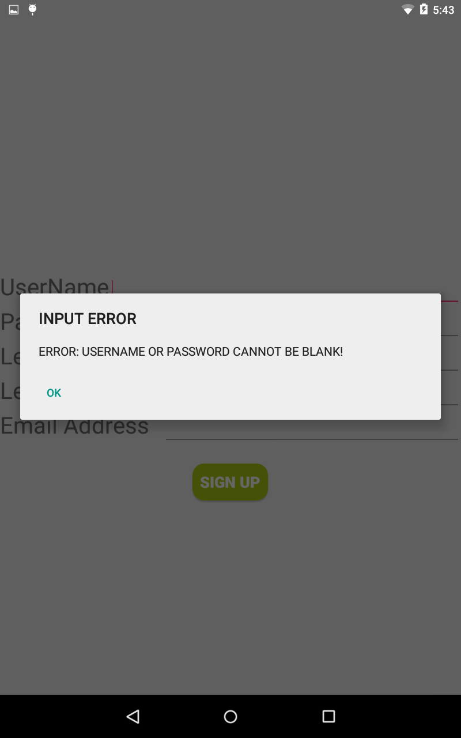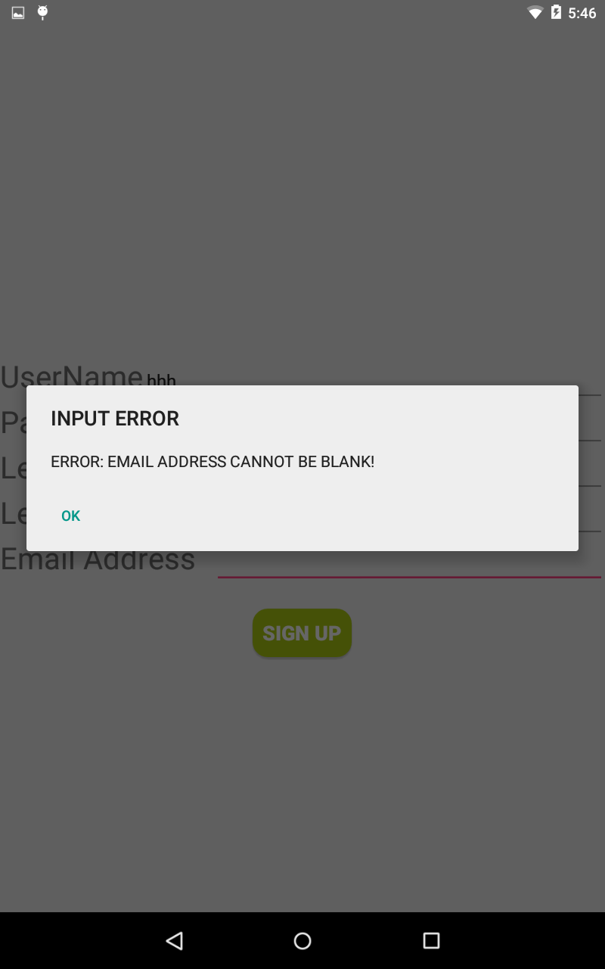 blank, you will receive an error message:

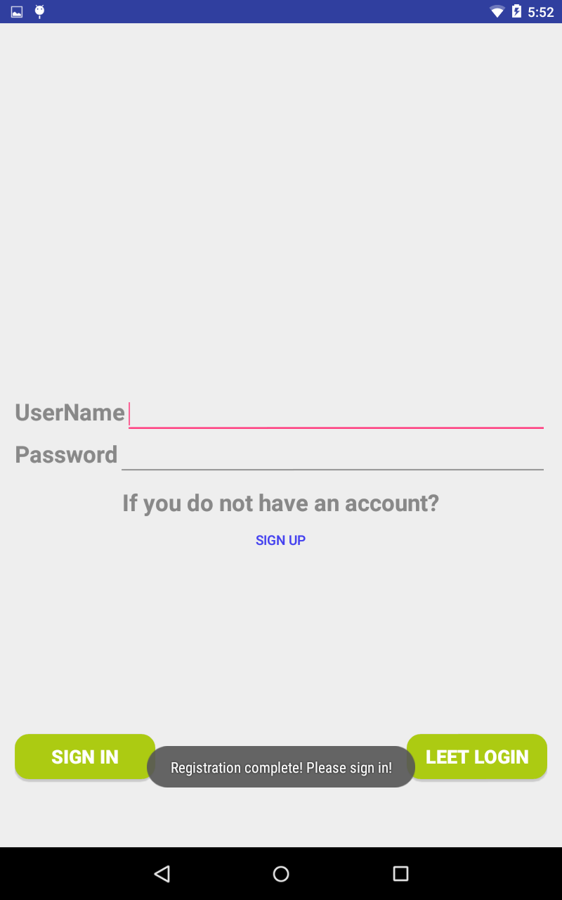After inputing the required items, you can click “SIGN UP” button to register your account in the database, which is running on the remote server. You will be back to the login page, where you can login with your newly created username and password:

Filling in the username and password, clicking “SIGN IN” button, you will see the main page of the APP.

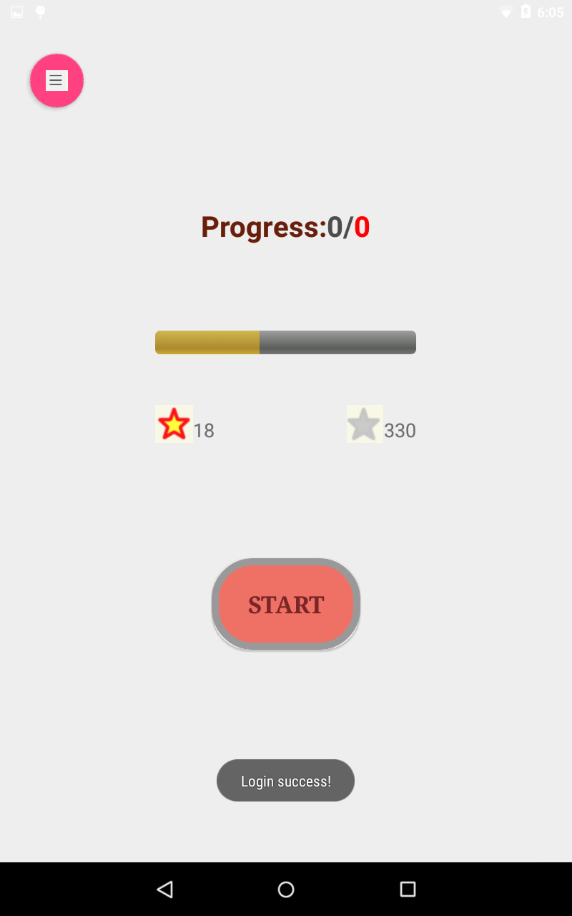

Test case 2:

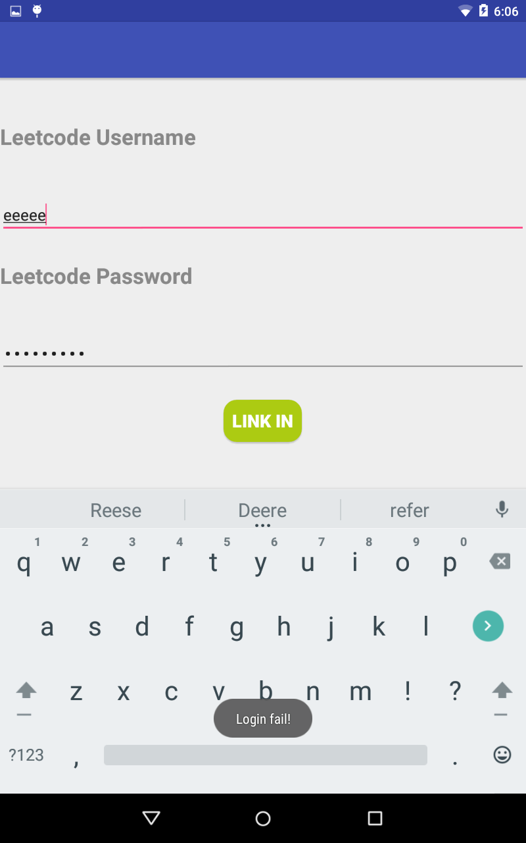Alternatively, it allows user login with your LeetCode credentials . By clicking the “LEET LOGIN” button on the log in page, another log in page will show up. You can input your LeeCode credential here.

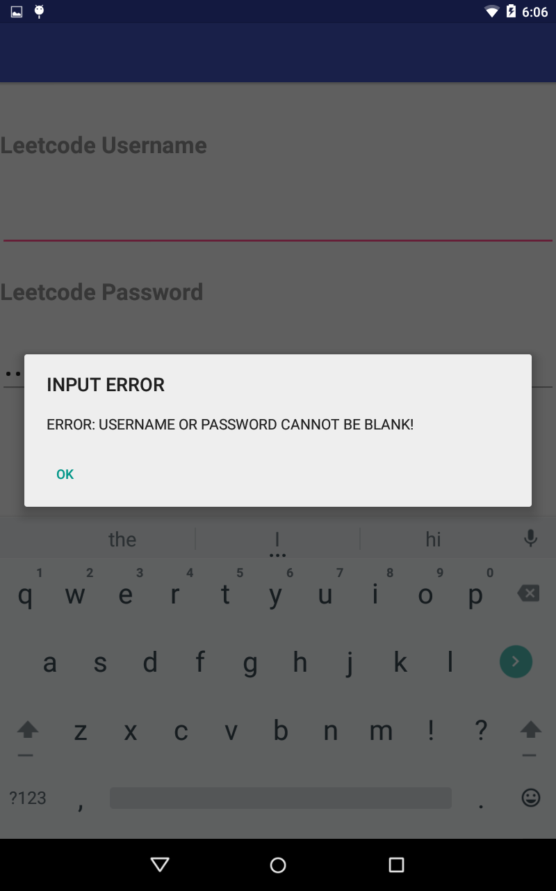Also, you will be required to input both your username and password correctly without leaving either blank.

Test Case 3: Set up your remind time and daily goal

After logging into the main page. You can set up your daily goal by clicking the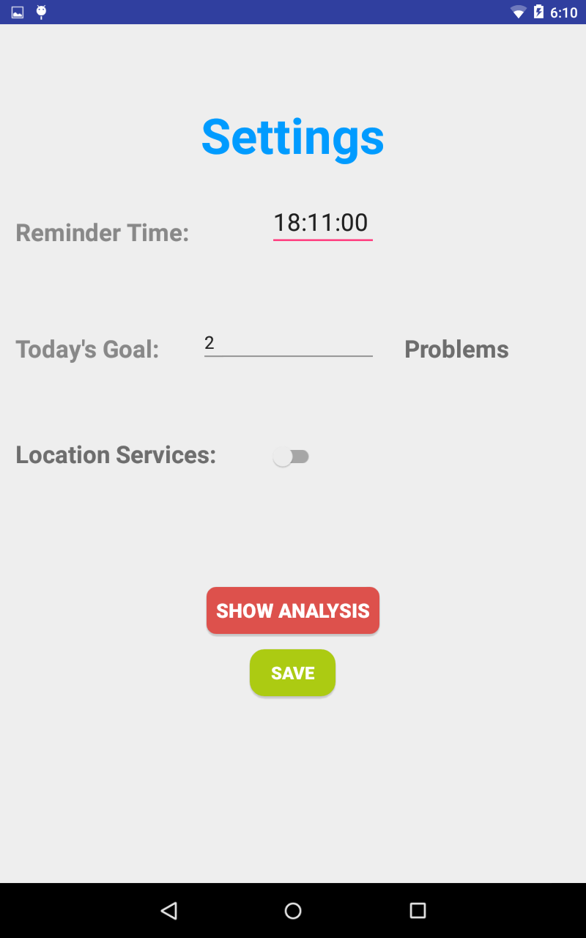 floating button on the left corner. A setting page will show up.

Here you can input your remind time, which means you will receive a daily notification on that time. Also, you should specify how many problems you want to solve per day.

After doing so, you can click “SAVE” button on the bottom. You should go back to main page now. And your daily goal and remind time will be remembered by the app.

Also, you can not leave the problem number blank or set it less than 0.

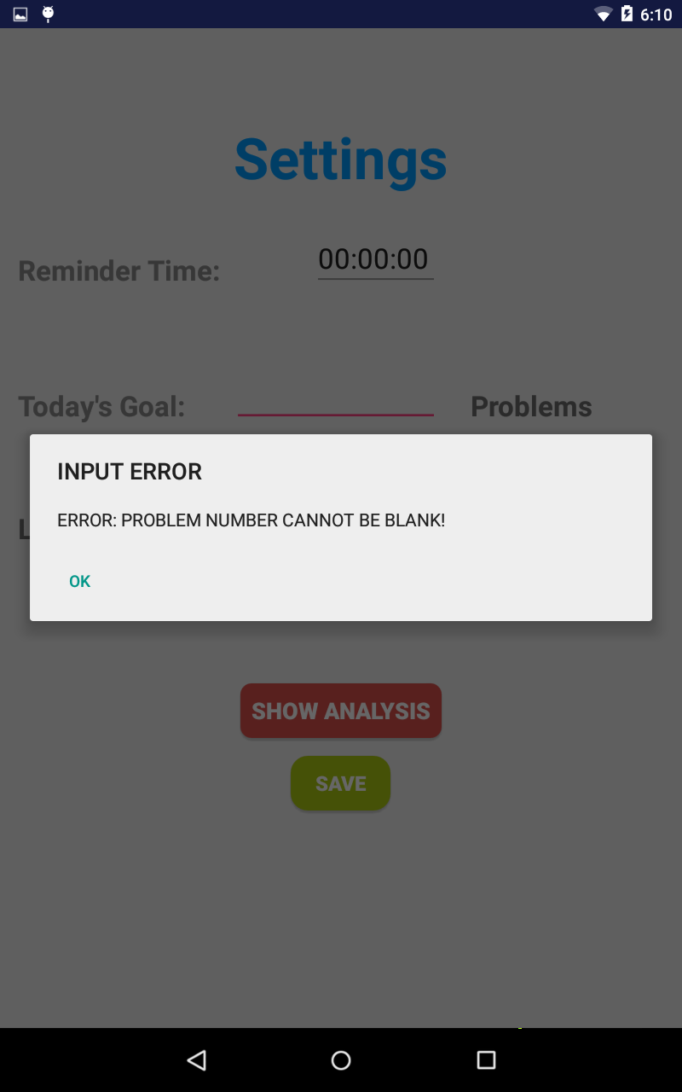

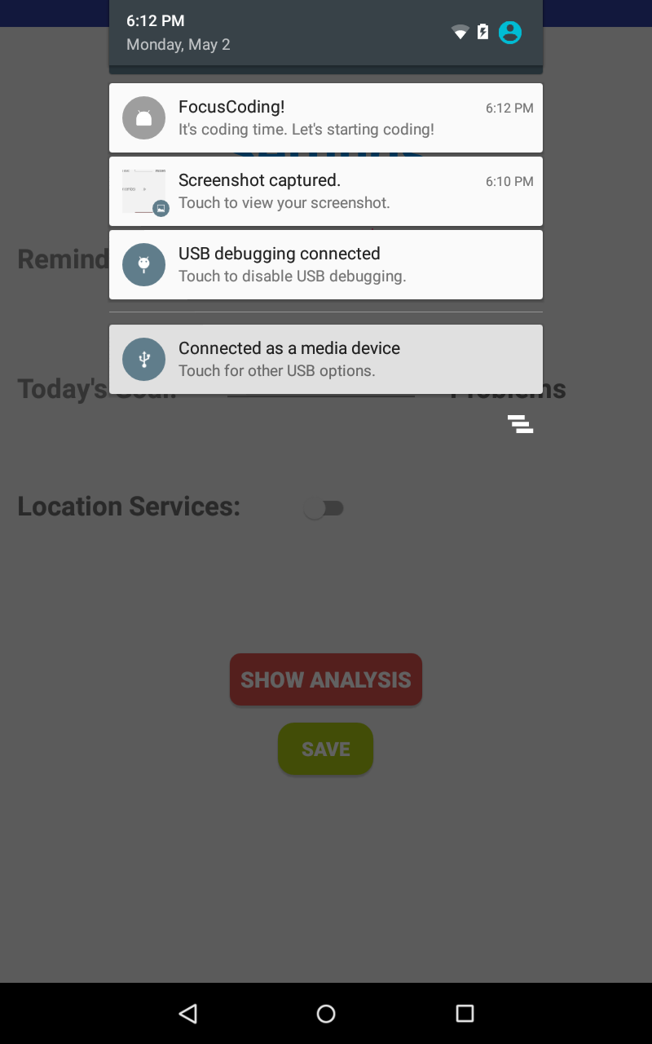As showed here, you will receive a notification on the time you set. By clicking on the notification, you will be lead to the sign in page of the app.

Test Case 4 : main page progress

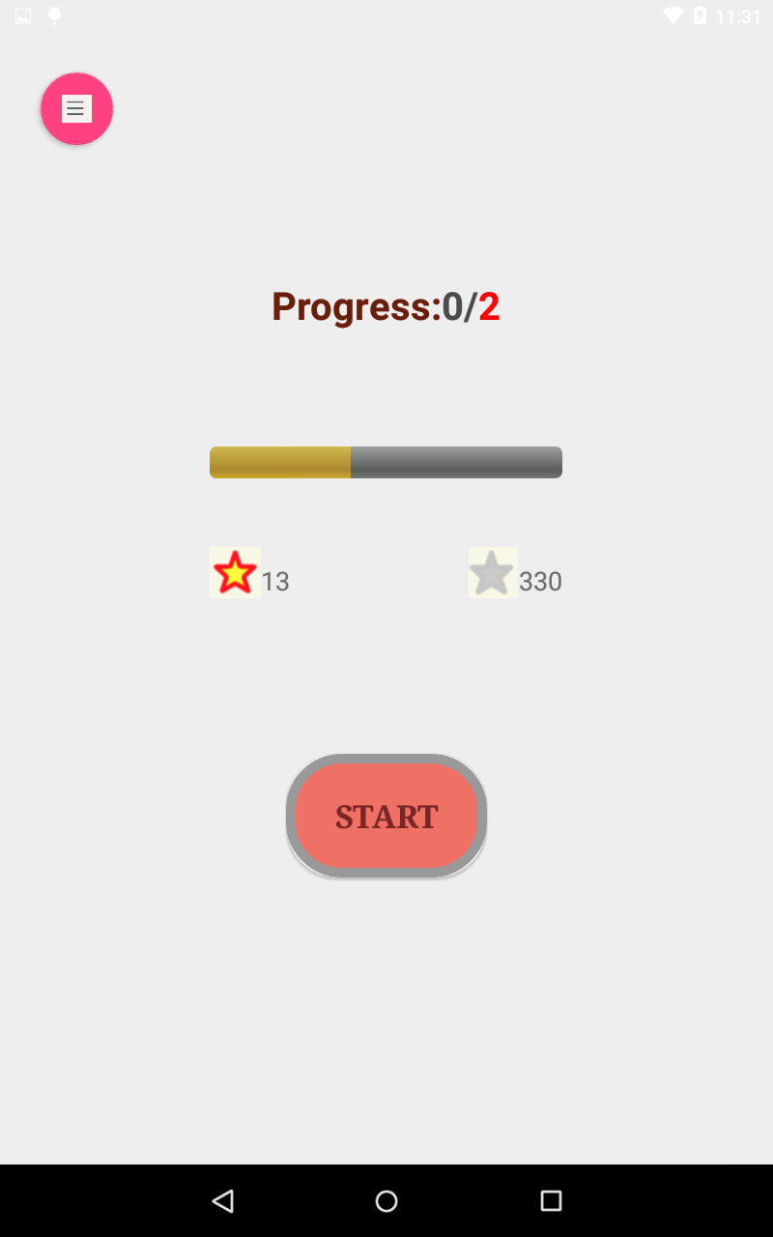After setting your goal, the progress state will be synchronized on the main page. As you can see, the default progress is 2 problems per day. And the red start will show you how many problems have been solved so far. The grey star shows you the total problem on LeetCode. the number is retrieved and synchronized with your LeetCode account.

Test Case 5 : Start coding

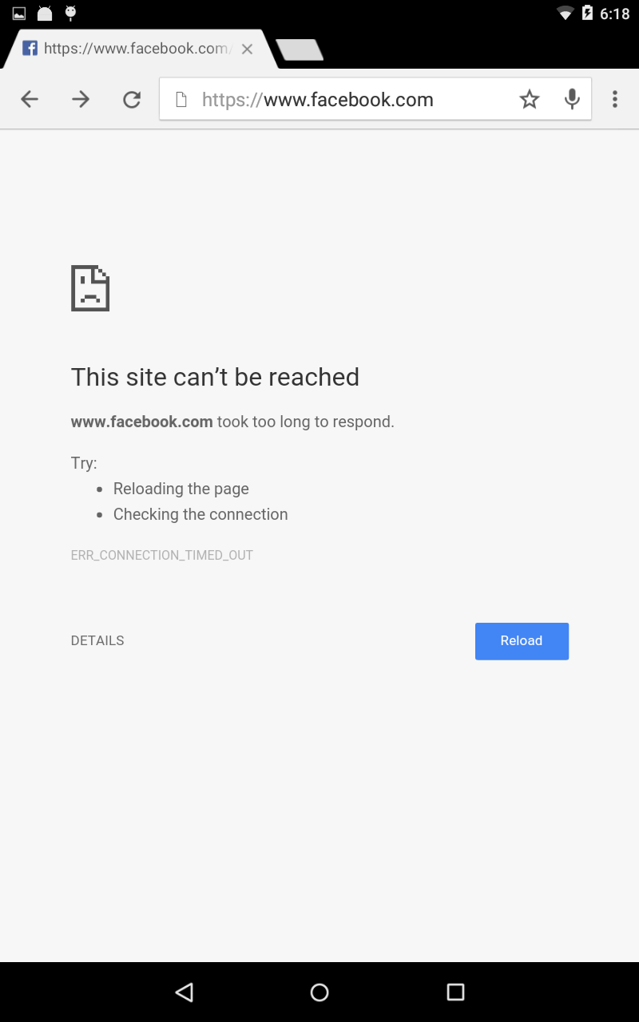By clicking the “START” button on the main page, you will start your coding process. After doing you, your access to Facebook will be blocked.

And a time counter will show up on the task page. You can start coding on LeetCode now.

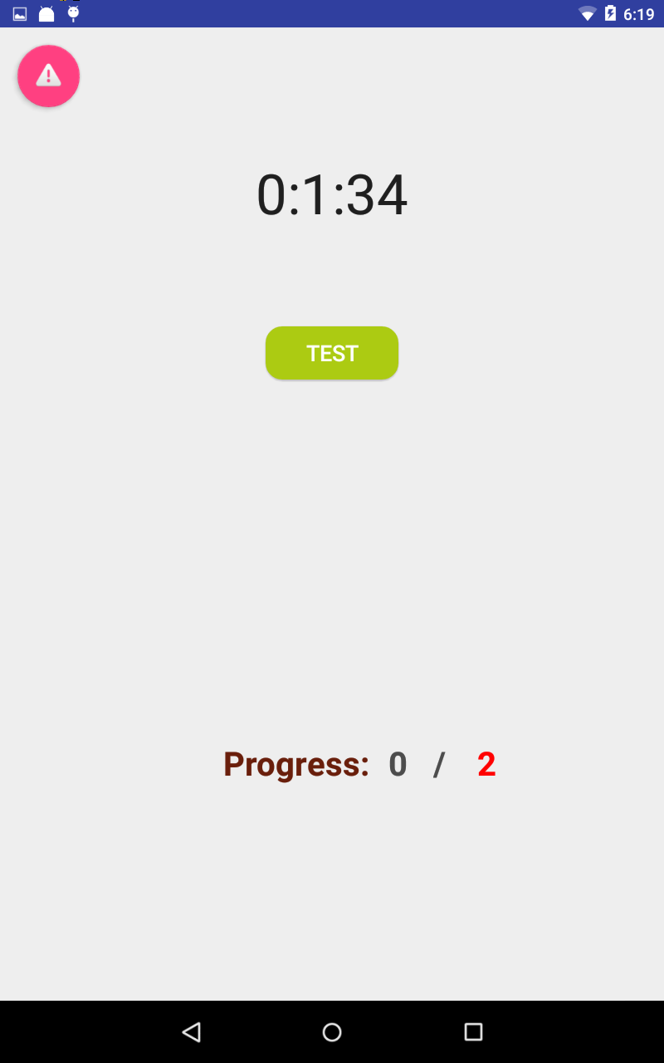

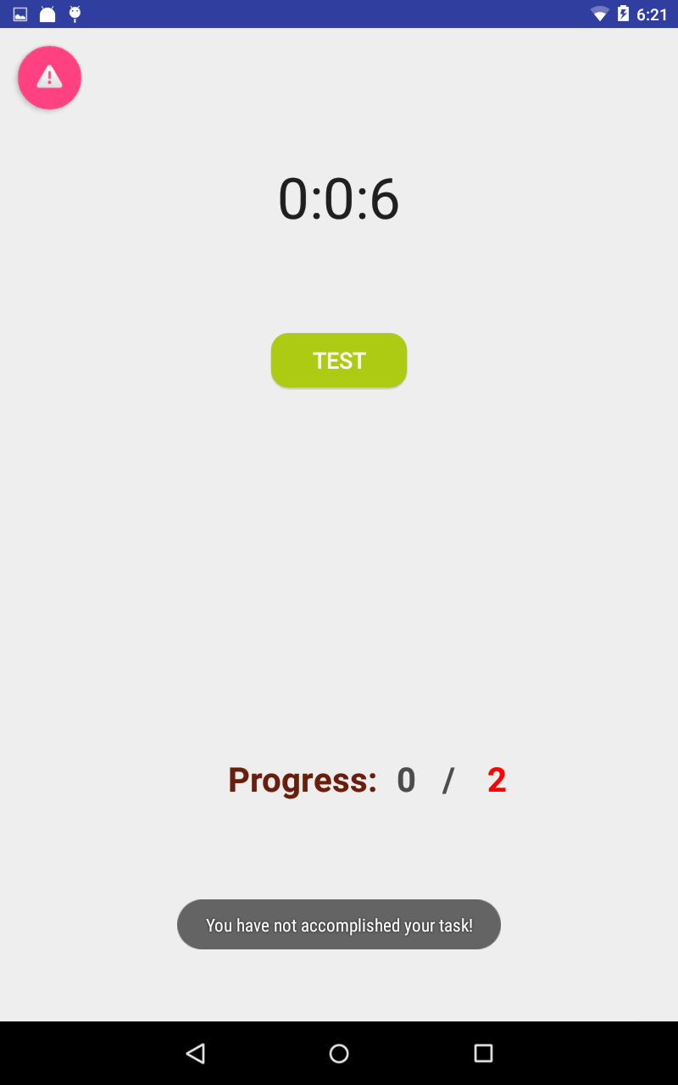After finishing the task, you can click ‘TASK’ button, the app will fetch the new status of your LeetCode account to check whether you have finished your daily task. If not, you will receive a message, you should continue then.

If you have finished the task, you will be back to the main page. And you should be fine with using Facebook again.

Test Case 5: pick one

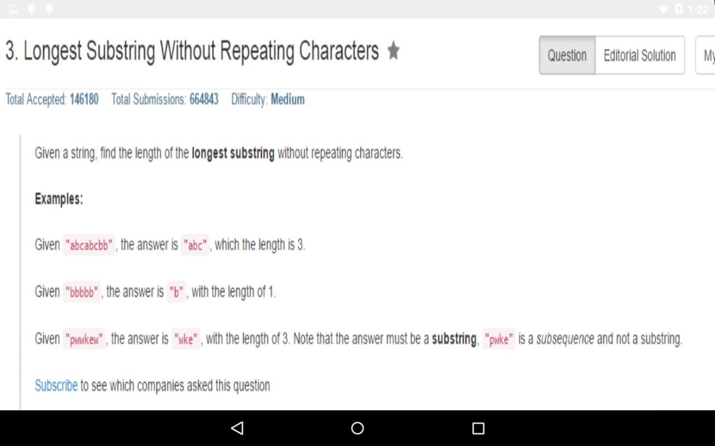In the task page, you can pick one problem randomly by clicking the floating button on the left corner. You can pick one by shaking your device. Here we use the gravity detector feature to detect the shake. You will see a problem show up now.



Test Case 6: Analysis

In the setting page, by clicking the “SHOW ANALYSIS” button, you will see, where is the location you solved most problems. Here we used the geographical location feature of the device and store the location information in the database.

